Parents’ guide to ePortal
You will receive an email from the college which will invite you to log on to eTrackr and create a password. The link will take you to the login screen.
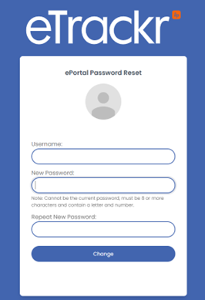
Your password needs to be more than 8 characters and contain letters and numbers.
You will then be emailed a code which you need to enter to log in. If you do not receive it please check junk or clutter.
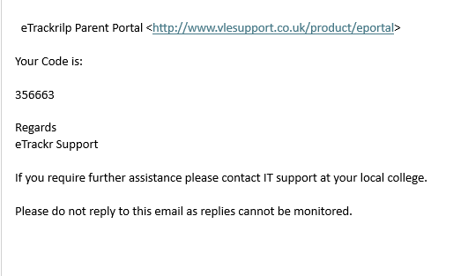
Once you have entered in your code, you will be logged on to eTrackr.
You will see a summary of the current progress of your son / daughter / ward.
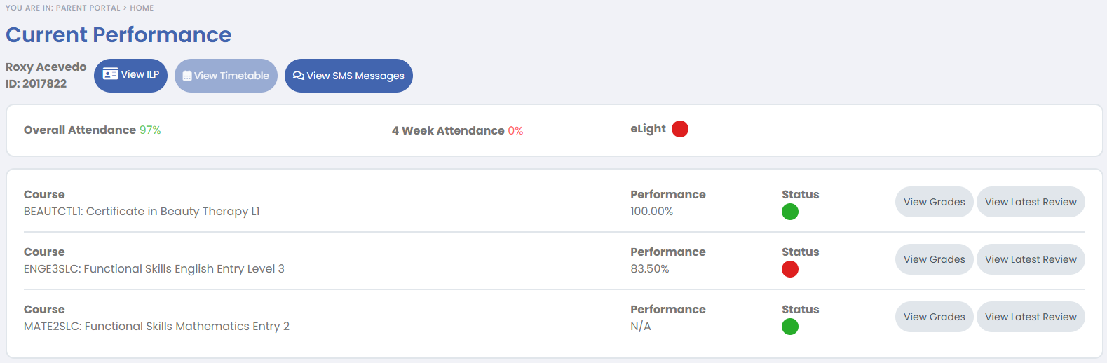

This will show you more detailed information about progress.
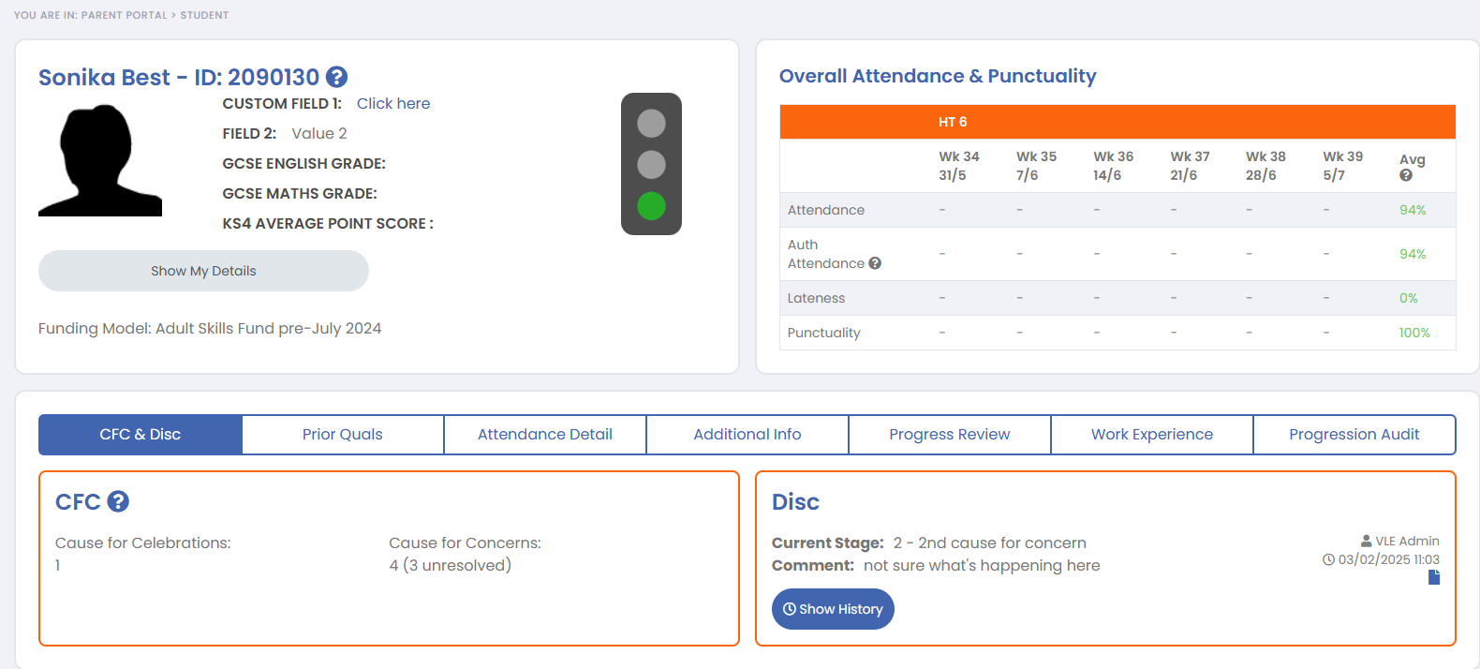

Here you will see the timetable (if this feature is set up).

Here you will see any text messages that have been sent to you.


The eLight can be Red / Amber or Green based on a number of factors, for example attendance, punctuality, concerns regarding behaviour or attendance and academic progress. If you hover over the light (on a desktop) or click on it (on a mobile phone) then it will tell you why the eLight is Red / Amber or Green.

This will show the hand out, hand in and assessment dates for each unit, as well as the Status, Performance and Grade where applicable.
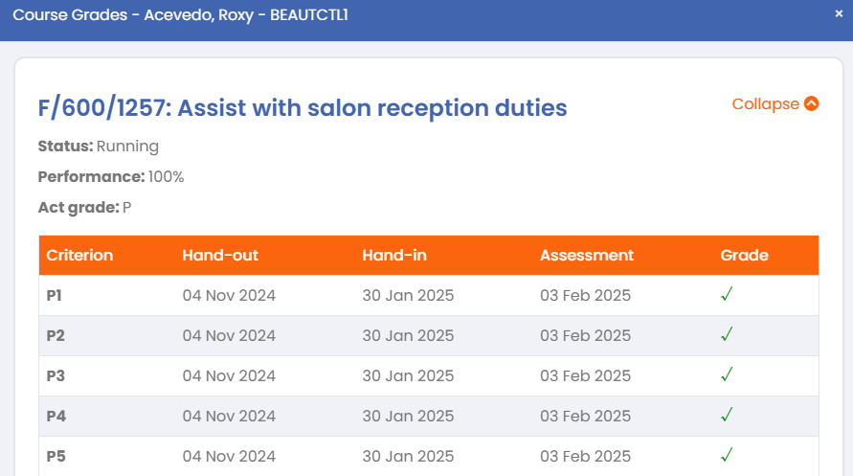

This will display the latest published Progress Review for this course.
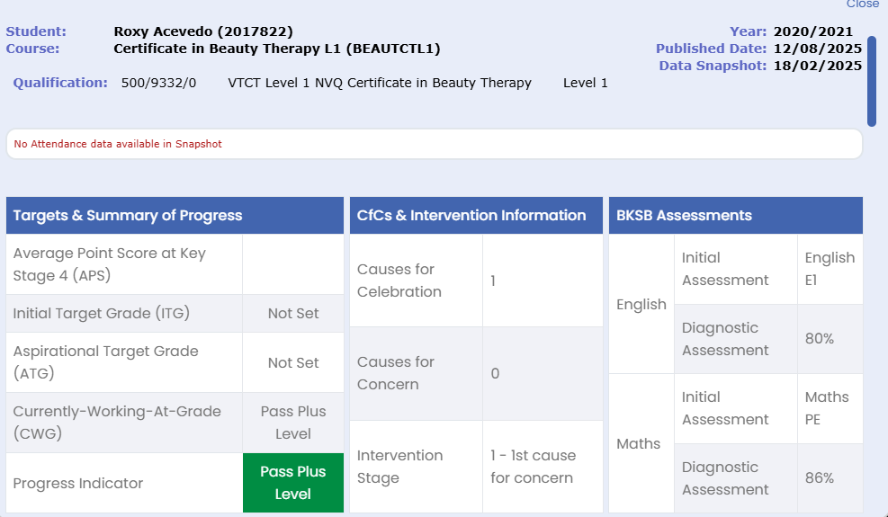

Forgotten Password
If you forget your password, they can use the Forgotten Password option from the sign in menu.
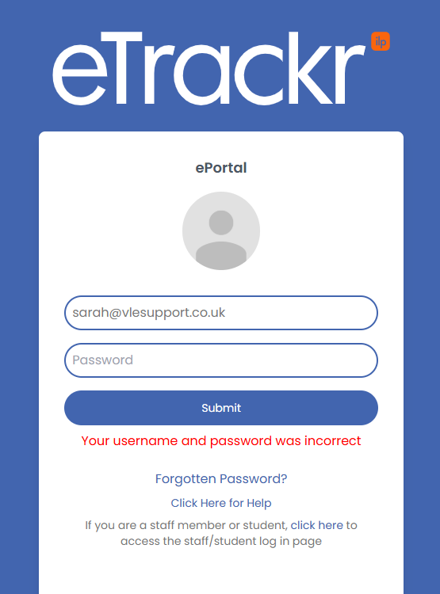
This will send you a password reset email.
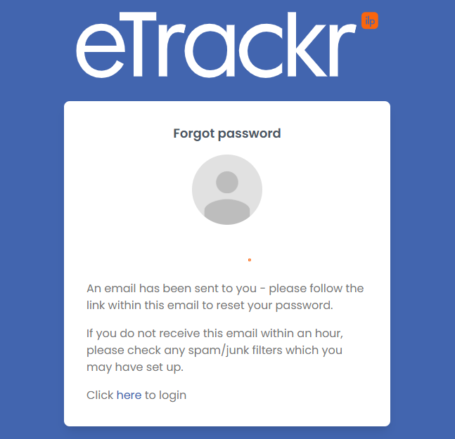
The link in the email will allow you to reset your password. Once done, you will get a confirmation email to say that the password reset was successful.

