|  |
| --- |
| **Job Description** |

|  |  |
| --- | --- |
| **Job Title** | **Safeguarding & Welfare Officer** |
| **Department** | **Students Services** |
| **Reports to** | **Safeguarding & Welfare Coordinator** |
| **Contract** | **Full time, Permanent** |
| **Scale** | **Business Support Pay scale (SO1) Spine 29 - 31** |
| **Location** | **East Ham and Stratford Campus** |

|  |
| --- |
| **Our Vision & Values** |

***“To develop the skills, confidence, and qualifications for local people to lead rich lives and build great careers. “***

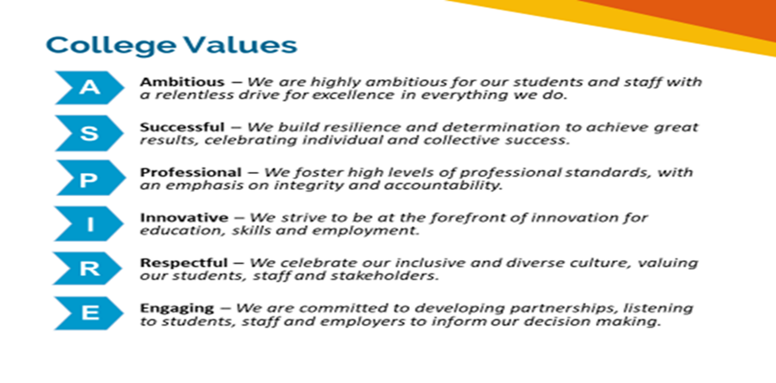

**Safeguarding of Children and vulnerable adults**

Newham College is committed to safeguarding and promoting the welfare of our learners and young people.  We expect all staff to share this commitment.  As this role involves regulated activity, the successful applicant will be required to undertake an enhanced DBS check and additional pre-employment checks.

**Equality of Opportunity**

The College has a strong commitment to working toward the implementation of equality of opportunity in both service delivery and employment. The College’s mission and strategic objectives directly support this aim. All employees are required to actively support the development, dissemination implementation of this aim and related policies and programmes.

We encourage and welcome applications from all individuals, regardless of age, disability, sex, sexual orientation, gender reassignment or identity, race, religion or belief and marriage and civil partnership.

|  |
| --- |
| **Job Purpose** |

Safeguarding & Welfare Officers play a leading role in ensuring the personal development of students, through promoting awareness of their role in modern society and through the provision of appropriate personal support that aims to remove barriers to achievement and maximise potential. Their aim is to develop excellent attitudes to learning, supporting students to become self-confident and resilient and know that they have the potential to be a successful student which will have a strong, positive impact on their progress. They will work closely with the Student Services and Curriculum teams to maximise student engagement and success.

The successful post holders will be expected to:

* Liaise with curriculum teams to target and provide pastoral and welfare support, dealing with an allocated caseload of students needing extra support, so that students develop the confidence and resilience needed to succeed.
* Act as part of the safeguarding team through the identification of students at risk or those experiencing mental ill health, who would benefit from support.
* Support the preparation of students for progression within and from the College.
* Contribute to the planning and delivery of enrichment activities and workshops so that students develop their understanding of citizenship, British Values, physical, emotional and mental health and the importance of personal, behavioural and social skills.
* Encourage student participation in wider College life, including enrichment and social action, equipping them with the skills and attributes needed in modern society.

|  |
| --- |
| **Key duties and responsibilities of the post** |

**These duties are not exhaustive or exclusive. The duties may be varied provided that any other duties are appropriate to the grading level of the post.**

1. Work with an allocated caseload of students, as determined through self-disclosure of health or social need or through referral by curriculum staff, to identify potential barriers to achievement and work with the students to address these and develop the confidence and resilience needed to succeed.
2. To be a named member of the safeguarding team and hold a key responsibility for the safeguarding of students, reporting safeguarding concerns in accordance with college policy and national legislation and guidance.
3. Work with the Safeguarding and Welfare Coordinator and Head of Student Experience (DSL) to raise awareness and deliver training regarding safeguarding themes and topics to staff and students, update information on posters, VLE and website.
4. Work with students in groups and one to ones so that they understand the skills and qualities that will support them making progress with their life goals and how action planning, their education and training, can equip them with the behaviours and attitudes necessary for employability and success in the future.
5. Work with these students to develop, implement and monitor support strategies, referring students to both internal and external support agencies and online platforms where appropriate.
6. Contribute to the delivery and implementation of enrichment activities that allow all students to explore personal, social, and ethical issues and take an active part in life in wider society, whilst promoting British and college values.
7. Help students to comply with college guidelines for behaviour and conduct and to help students manage their own behaviour in the College.
8. Ensure students receiving support or intervention from student services are allocated with the correct risk indicators on the safeguarding systems.
9. Liaise effectively with all other support services such as counselling, bursary, and additional learning support to offer a full range of support for students.
10. Contribute to students’ understanding of their rights and responsibilities as a student and as citizens in the community; and how well they work cooperatively with others in all settings and promote good and productive working relationships with their peers.
11. Work as an active member of the Student Services Team alongside the Safeguarding and Welfare Coordinator and Head of Student Experience (DSL) in the self-assessment process for the team. Support a culture of continuous improvement through contributing to the use of rigorous self-assessment processes.
12. Implement strategies to maintain a safe working environment, adopting procedures and practices to ensure safe working conditions and ensuring students and staff comply with any relevant safety standards.
13. Support the Safeguarding and Welfare Coordinator in the preparation of enrichment materials to ensure effective promotion of the elements of Personal, Social and Employability skills, Equality, Diversity and Inclusion and Safeguarding.
14. Liaise with parents, carers, and external agencies, where applicable, establishing effective working relationships and providing timely and accurate information.
15. Work with other departments to provide relevant information, advice, and guidance to prospective students, e.g., open days, Interview session, enrolment and student events.

|  |
| --- |
| **Person specification:** |

This person specification will be used in short-listing and in interviewing for selecting the best candidate. Each applicant is, therefore, advised to address each aspect of the person specification in his / her written application.

The methods by which each of the selection criteria are expected to be assessed are identified in the table.

AF = Application Form I = Interview

|  |  |  |  |
| --- | --- | --- | --- |
|  | **Desirable** | **Essential** | **Assessed by** |
| Knowledge |  |  |  |
| 1. Knowledge of key developments relating to child protection and safeguarding. |  | Y | AF/I |
| 1. Knowledge of frameworks, legislation, regulations, and requirements of the sector and how these relate to the role. |  | Y | AF/I |
| 1. Knowledge of the national and local priorities for young people and adults. |  | Y | AF |
| **Abilities/Skills/Experience** |  |  |  |
| 1. Experience of making positive impact through working directly with young people aged 14-19 and 19+ involving the assessment of needs and provision of advice, information, and support. |  | Y | AF/I |
| 1. Experience of working with young people and adults to develop their employability, social, behaviour and personal skills to successfully achieve their programme of study. |  | Y | AF |
| 1. Experience of working with several different support agencies, both within an education setting or in the wider community, for example signposting students with mental health concerns to the appropriate support service. |  | Y | AF/I |
| 1. An understanding of and empathy with the challenges of working with learners from diverse backgrounds. |  | Y | AF/I |
| 1. Have excellent interpersonal skills needed to develop positive and supportive professional relationships with students, teachers, parents/carers, external agencies, and the wider community. |  | Y | AF/I |
| 1. Experience of coaching, motivational or counselling techniques and the ability to motivate others to reach their full potential. |  | Y | I |
| 1. Good communication skills both written and oral to include being able to maintain accurate and up to date records in a timely fashion. |  | Y | I |
| 1. Initiative and ability to prioritise one’s own workload and work to tight deadlines. |  | Y | I |
| 1. Ability to improve own practice/knowledge through self-evaluation and learning from others. |  | Y | AF/I |
| 1. Knowledge and experience of using ICT packages systems and equipment effectively. |  | Y | AF |
| 1. The ability to interpret data using management information skills. |  | Y | AF |
| 1. Experience of delivering tutorials/and or workshops on matters relating to safeguarding and Prevent. |  | Y | AF/I |
| 1. Ability to work across different sites within Newham Borough |  | Y | AF |
| 1. Ability to recognise and manage your own stress triggers and put strategies in place to mitigate |  | Y | I |
| **Qualifications and further professional development** |  |  |  |
| 1. Level 2 in Maths and English or equivalent. |  | Y | AF |
| 1. Level 3 Safeguarding Trained (DSL cert) |  | Y | AF |
| 1. Mental Health 1st Aid Trained | Y |  |  |
| 1. Willingness to take part in all relevant training and evidence of recent professional development and its impact. Willingness to share good practice with others. |  | Y | I |
| 1. Demonstrable commitment to Equality and Diversity, Safeguarding, Health & Safety and Personal, Social & Employability skills. |  | Y | I |

**Essential Criteria:**

* Are you Level 3 DSL trained?
* Have worked with or can demonstrate working/dealing with people aged 14-18 and 19+
* Have you worked in Education for 2 years.
* Have you worked in Safeguarding or Welfare for 2 years +

**Please note:** Prior to confirming an appointment to the college, individuals are asked to complete a medical questionnaire in order that the College’s Medical Health Contractor can ascertain their medical fitness for the post.